**GC Log Analysis for Load Testing:**

After looking at the summary of the GC logs in below table it is clear that the throughput is almost constant. Although the pauses increase with the number of users accessing the system the throughput has been consistent at 98-99 % at an average for all the configurations which proves that the application is working reliably under load. There are very few pauses on average of 32 and pause time of 4.10s at average for most of the configurations which can be reduced with optimisation

|  |  |  |  |  |  |  |  |  |  |  |
| --- | --- | --- | --- | --- | --- | --- | --- | --- | --- | --- |
| Configuration | Users | Footprint | Freed Memory | Freed Mem/Min | Acc pauses | Throughput | Number of full gc pauses | Full GC Performance | Number of gc pauses | GC Performance |
| Config3 |  |  |  |  |  |  |  |  |  |  |
|  | 50 | 351.1 M | 2517.8 M | 465.786 M/m | 3.64s | 98.88% | 3 | 13.2 M/s | 25 | 1256.7 M/s |
|  | 100 | 349.5 M | 3506.5 M | 524.443 M/min | 4.47s | 98.89% | 3 | 11.5 M/s | 33 | 1312.9 M/s |
|  | 200 | 350.9 M | 3391.2 M | 494.429 M/min | 3.61s | 99.12% | 3 | 16 M/s | 32 | 1524.1 M/s |
|  | 500 | 321.7 M | 3609.6 M | 129.421 M/min | 3.65s | 99.78% | 3 | 12.9M/s | 34 | 1560.4 M/s |
|  | 1000 | 360.9 M | 3712.9 M | 446.814 M/min | 3.64s | 99.27% | 3 | 15.2M/s | 34 | 1679 M/s |
|  | 2000 | 341.8 M | 3661.4 M | 434.825 M/min | 4.21s | 99.17% | 3 | 12.9M/s | 34 | 1458.8 M/s |
|  |  |  |  |  |  |  |  |  |  |  |
| Config5 |  |  |  |  |  |  |  |  |  |  |
|  | 50 | 367.7 M | 3284.8 M | 486.136 M/m | 4.72s | 98.84% | 3 | 10.8 M/s | 32 | 1274.6 M/s |
|  | 100 | 349.4 M | 3424.8 M | 509.596 M/m | 4.54s | 98.87% | 3 | 10.6 M/s | 32 | 1340.7 M/s |
|  | 200 | 348.4 M | 3543.5 M | 509.376 M /m | 3.66s | 99.12% | 3 | 15.3 M/s | 33 | 1556.8 M/s |
|  | 500 | 355.2 M | 3390.8 M | 477.428 M/m | 3.85s | 99.10% | 3 | 14 M/s | 32 | 1436.1 M/s |
|  | 1000 | 354.1 M | 3366.2 M | 425.138 M/m | 4.6s | 99.03% | 3 | 12.8 M/s | 32 | 1163.1 M/s |
|  | 2000 | 355.2 M | 3540.4 M | 403.852 M/m | 5.13s | 99.02% | 3 | 11 M/s | 33 | 1104.1 M/s |
|  |  |  |  |  |  |  |  |  |  |  |
| Config6 |  |  |  |  |  |  |  |  |  |  |
|  | 50 | 348.5 M | 3304.7 M | 451.649 M/m | 3.43s | 99.22% | 3 | 16.2 M/s | 31 | 1547.2 M/s |
|  | 100 | 353.6 M | 3549.8 M | 540.092 M/m | 3.87s | 99.02% | 3 | 13.3 M/s | 33 | 1570.6 M/s |
|  | 200 | 353.4 M | 3669.8 M | 528.276 M/m | 4.46s | 98.93% | 3 | 11.5 M/s | 34 | 1393.2 M/s |
|  | 500 | 364.1 M | 3769.9 M | 134.342 M/m | 4.15s | 99.75% | 3 | 14.1 M/s | 37 | 1551.2 M/s |
|  | 1000 | 356.4 M | 3678.8 M | 438.763 M/m | 4.6s | 99.09% | 3 | 11.3 M/s | 34 | 1343.3 M/s |
|  | 2000 | 348.6 M | 3934.6 M | 464.343 M/m | 4.71s | 99.07% | 3 | 11.3 M/s | 36 | 1382.3 M/s |
|  |  |  |  |  |  |  |  |  |  |  |
| Config8 |  |  |  |  |  |  |  |  |  |  |
|  | 50 | 350.1 M | 3296.2 M | 469.986 M/m | 4.36s | 98.96% | 3 | 10.8 M/s | 31 | 1407.4 M/s |
|  | 100 | 344.3 M | 3406.3 M | 530.515 M/m | 3.78s | 99.02% | 3 | 14.8 M/s | 32 | 1452.4 M/s |
|  | 200 | 371.5 M | 3459.9 M | 493.05 M/m | 3.76s | 99.11% | 3 | 16.4 M/s | 34 | 1454.8 M/s |
|  | 500 | 355.9 M | 3530.9 M | 478.576 M/m | 4.48s | 98.99% | 3 | 12 M/s | 33 | 1308 M/s |
|  | 1000 | 359.6 M | 3553.6 M | 428.797 M/m | 3.6s | 99.28% | 3 | 15.5 M/s | 33 | 1651.4 M/s |
|  | 2000 | 368.2 M | 3642.5 M | 432.306 M/m | 4.36s | 99.14% | 3 | 11.4 M/s | 35 | 1449.3 M/s |
|  |  |  |  |  |  |  |  |  |  |  |
| Config 10 |  |  |  |  |  |  |  |  |  |  |
|  | 50 | 350.7 M | 3287.9 M | 479.381 M/m | 3.36s | 99.18% | 3 | 16.4 M/s | 31 | 1605.7 M/s |
|  | 100 | 343.9 M | 3394.4 M | 510.699 M/m | 3.88s | 99.03% | 3 | 12.7 M/s | 32 | 1580.1 M/s |
|  | 200 | 350.4 M | 3548.3 M | 515.224 M/m | 3.65s | 99.12% | 3 | 13.8 M/s | 33 | 1677.7 M/s |
|  | 500 | 359.3 M | 3392.2 M | 476.631 M/m | 3.96s | 99.07% | 3 | 12.3 M/s | 32 | 1511.4 M/s |
|  | 1000 | 361.4 M | 3716.6 M | 441.5 M/m | 4.48s | 99.11% | 3 | 10.3 M/s | 34 | 1550.9 M/s |
|  | 2000 | 353.6 M | 3516.7 M | 123.3 M/m | 4.32s | 99.75% | 3 | 12.4 M/s | 33 | 1338.9 M/s |

We have attached below some screenshots from GC Viewer for different loads for only Config3. Note: Only Config3 screenshots have been added. Please refer to Config3 in above table for below screenshots

**Scenario: Load test for 50 Users:**

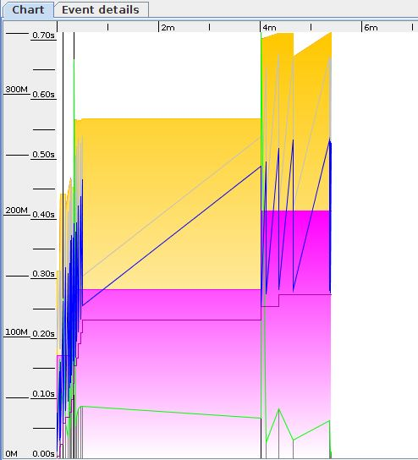 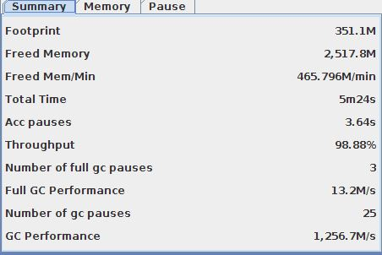

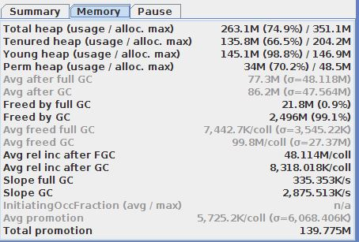 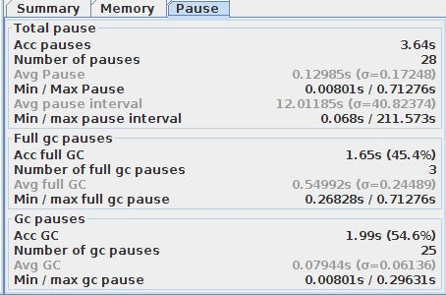

**Scenario: Ran Load test for 100 Users**

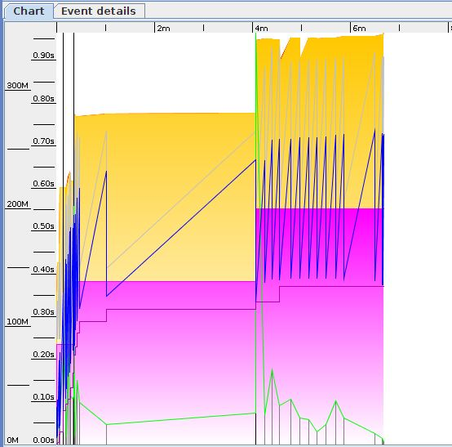 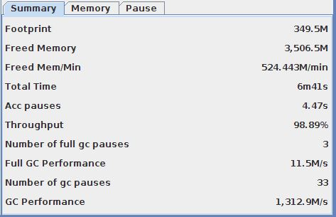

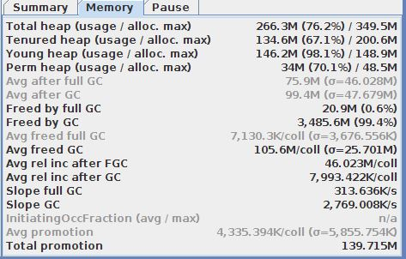 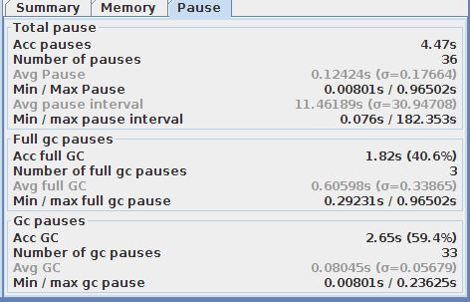

**Scenario: Ran Load test for 200 Users**

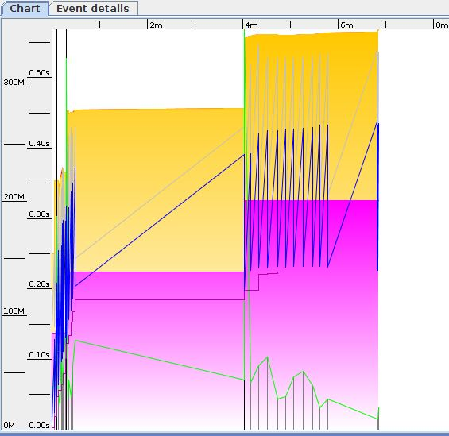 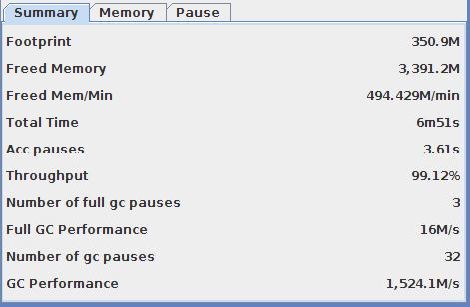

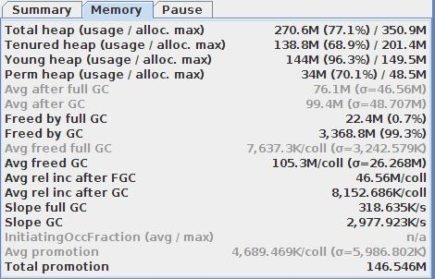 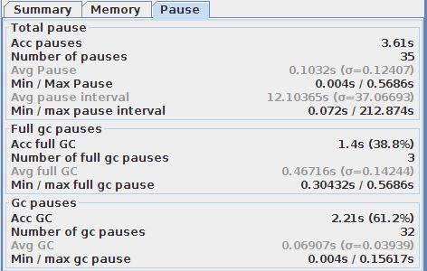

**Scenario: Ran Load test for 500 Users**

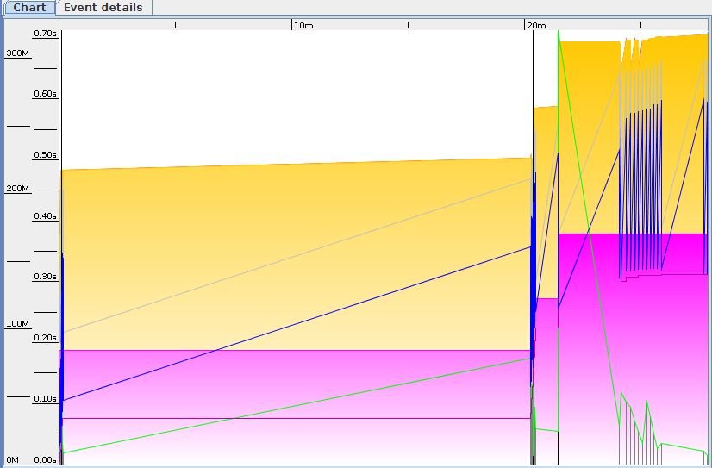 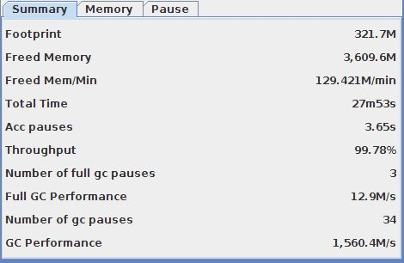

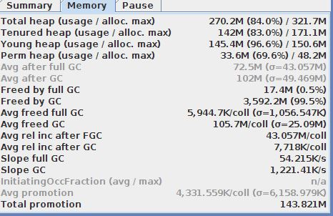 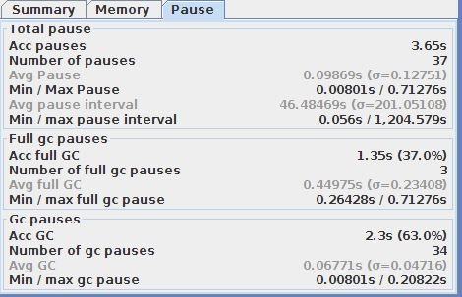

**Scenario: Ran Load test for 1000 Users**

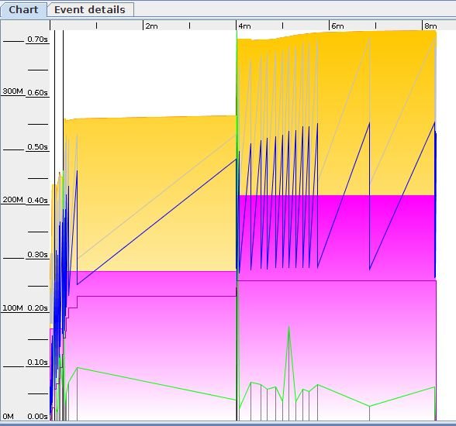 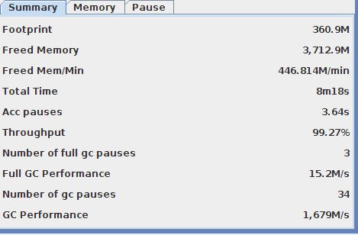

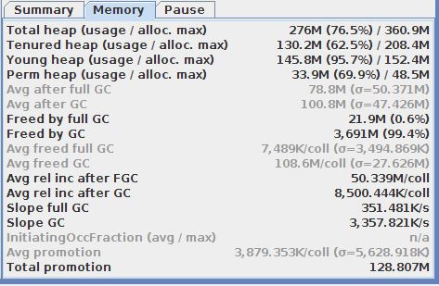 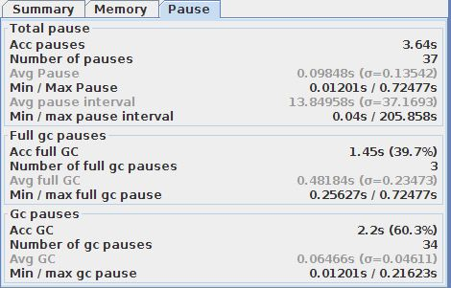

**Scenario: Ran Load test for 2000 Users**

